Mrs. Schell’s DK.

News - October 4-8, 2021

 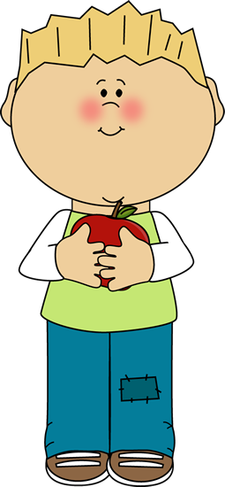

**A Peak at the Week** ; This week are theme was “Leaves” in our Fall unit We gathered leaves outside at recess. We talked about the fall and leaves changing colors We sand the song”All the leaves are falling down” We are did a lot of art projects with leaves::Leaf prints ,and leaf rubbings. We continue with Eureka Math, Handwriting Without Tears and Story Champs. We are learning all kinds of songs. We are also doing the Alphachant Letter “C””. Our classroom sure is busy

                                                                                             

|  |  |  |
| --- | --- | --- |
|  |  |  |
|  | was the class favorite! |  |
|  |  |  |

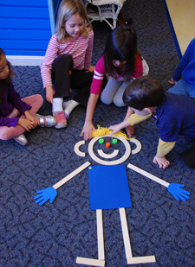

From classroom personality to storybook hero, Mat Man™ is a favorite among young children. Children first meet this charming character through the Handwriting Without Tears® Build Mat Man activity. Mat Man teaches important readiness skills:

* Body awareness
* Drawing & pre-writing
* Counting
* Building

Socializing & sharing

Math Mania

This week we worked on: Sorting and Counting orally from 0-10

Activities to do at home: Have your child sort, match and name coins at home. Count with your child often. Counting can be done almost anywhere. The car is a great place to count.

**School / Home Connection**





*FOLDERS*Every Friday, students will bring home their blue folders that may contain papers for parents and/or completed student work.  Please empty out the folders and have them keep their folders in their bags so that they can pack them up again the following week.   (If they keep forgetting, let me know and I'll ask them to check their bag!)

**Wednesday and Fridays are Gym days please were tennis shoes.**

If you call during the school day.I may not be able to call you back until my prep or after school. The best way to reach me during the school day is to email me at cathy.schell@fraserk12.org 

Please visit our classroom website at

http://dkdooleycenter.weebly.com

Rest time stuff goes home every Friday to be washed and returned on Monday

 

Dates to remember: October 13th and 29th EARLY RELEASE

Picture day October 13 and 14th I will send a note home which day is ours

**Cold Weather**

* Please make sure your child is wearing warm enough clothing for playing outside. Some jackets are not thick/warm enough for cold weather. Also, make sure they are learning the skills of getting dressed by allowing them to put on their clothes all by themselves.

## Reporting your child’s absence:

## If your child is feeling sick or maybe your family is going out of town you need to report your child’s absence for any reason to the attendance line: 586.439.7690

Water Bottles

I am fine with having water bottles in the classroom. Please make sure the bottle is marked with your child’s name!

**FYI.**

According to the National Sleep Foundation children 3 or 4 should get between 11 to 13 hours of sleep daily, this may include a daily nap. Children between the ages of 5 – 12 should get 10 to 11 hours of sleep. A lack of sleep can affect a child’s attention span and their ability to think clearly.



Next Week we will continued our Fall Unit and focus on “ Fall and Fire Saftey



Smiles Mrs. Schell 